COURSE CODE/TITLE: | CPE010 |  | SECTION: | CPE21S4
DATE PERFORMED: | July 17 2026 |  | DATE SUBMITTED: | July 17, 2026
NAME: | Cardenas, Lea Marie N. |  | INSTRUCTOR: | Engr. Jimlord Quejado

ACTIVITY NO. 2.1 | ARRAYS, POINTERS AND DYNAMIC MEMORY ALLOCATION
1. PROCEDURE OUTPUT
What procedures did you perform?
Implement static and dynamic memory allocation & ILO B: Create dynamically allocated objects
using pointers and arrays

Table 2-1. Initial Driver Program

Screenshot | 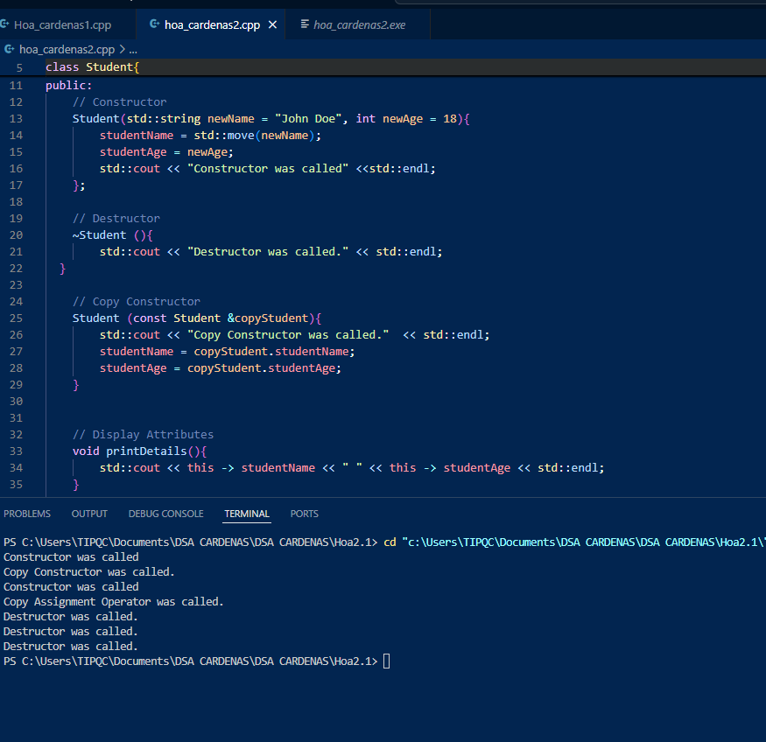
Observation

Table 2-2. Modified Driver Program with Student Lists
Screenshot | 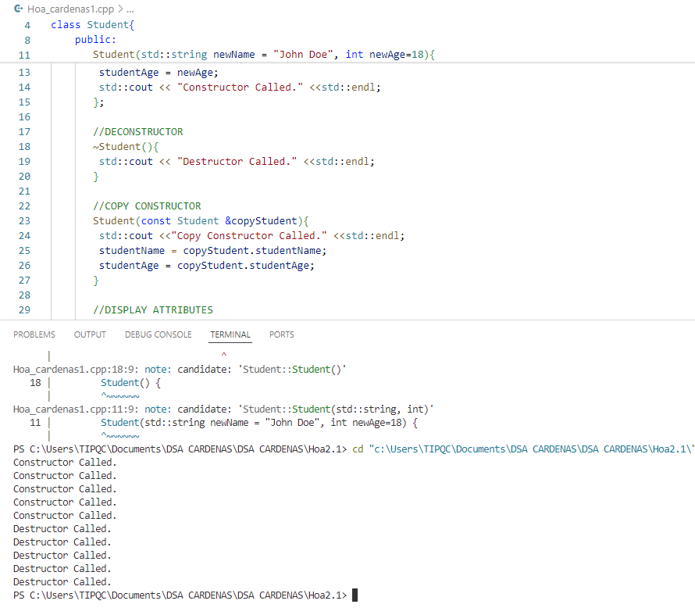
Observation | - In my observation, I used to follow my prof's demonstration in C++ output. I created and managed dynamic objects using pointers and arrays. The contractor and destructor messages confirmed that my memory allocation and deallocation code worked correctly.

.

Table 2-3. Final Driver Program

screenshot
Observation

2. ANSWERS TO SUPPLEMENTAL ACTIVITY
Copy and paste the questions from the lab and include your answers after.

3. ARTIFICIAL INTELLIGENCE (AI) USE DISCLOSURE STATEMENT
I hereby declare that artificial intelligence (AI) tools were used, if applicable, in the preparation of this academic work. The following indicates the nature and extent of AI assistance:

Tools Used:
Examples: ChatGPT, Microsoft Copilot, Grammarly, QuillBot, etc.

Purpose of Use:
Examples: grammar correction, idea generation, formatting, summarization, code assistance, explanation of concepts, etc.

Extent of Use:
Explain how AI was used and confirm that it did not replace original thinking, analysis, authorship, or completion of the required work.

By submitting this activity, I affirm that my use of AI complies with T.I.P.’s AI usage policy and does not exceed the permitted limits for similarity, automated content generation, or academic assistance.

I understand that any false, incomplete, or misleading disclosure may be subject to investigation in accordance with due process and may result in sanctions for violation of existing T.I.P. policies.

Lab activities, templates, and related instructional materials shall not be reuploaded, reproduced, distributed, or shared with external organizations or third parties without the prior express written permission of the Technological Institute of the Philippines.

